|  |
| --- |
|  |
|  |
|  |
|  |
|  |

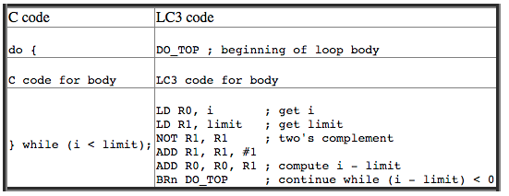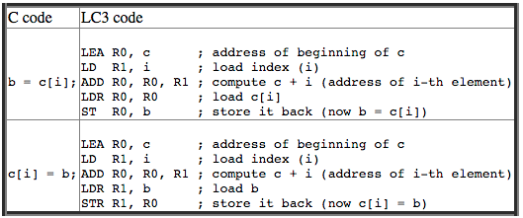

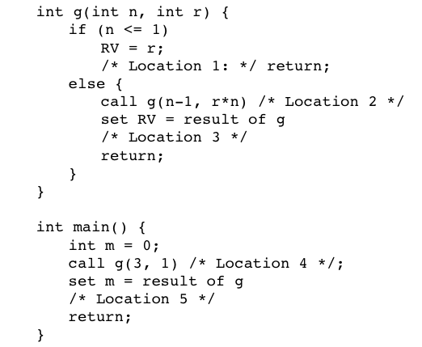

|  |  |  |
| --- | --- | --- |
| **At Location 1:**  For g:  Location 9: DL = Location 8  RA = Location 2  RV = 6  n = 1  r = 6  For g:  Location 8: DL = Location 7  RA = Location 2  RV = 0  n = 2  r = 3  For g:  Location 7: DL = Location 6  RA = Location 4  RV = 0  n = 3  r = 1  For main:  Location 6: m = 0;  DL = null  RA to OS  RV = 0 | **At Location 3:**  For g:  Location 8: DL = Location 7  RA = Location 2  RV = 6  n = 2  r = 3  For g:  Location 7: DL = Location 6  RA = Location 4  RV = 0  n = 3  r = 1  For main:  Location 6: m = 0;  DL = null  RA to OS  RV = 0  **At Location 3:**  For g:  Location 7: DL = Location 6  RA = Location 4  RV = 6  n = 3  r = 1  For main:  Location 6: m = 0;  DL = null  RA to OS  RV = 0 | **At Location 5:**  For main:  Location 6: m = 6;  DL = null  RA to OS  RV = 0 |